# Short Experior - Robot Studio interface description

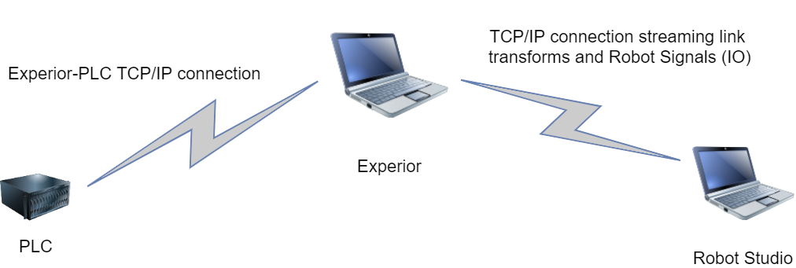

**Robot Studio signals:**

When exporting the IO list from Robot Studio to Experior you have 2 options: PLC or Gripper IO.

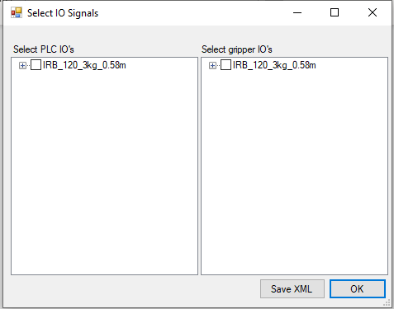

Assume in the following description we have a Robot output signal.

If the signal is marked as “Gripper IO” it is sent to the “robot controller” object in Experior which then passes the signal to the gripper inside Experior. Example of use: Activate and deactivate a vacuum gripper.

If the signal is marked as “PLC IO” it is also sent to Experior. But in Experior it is converted to a normal “PLC input” object which then passes the value to the PLC (Siemens, Beckhoff, etc).

In the “robot controller” object in Experior you need to “connect the wire”. Select the Robot inputs and outputs where you find the signal name from Robot Studio as “Description”. Configure with the correct PLC values (tags or bit and byte number depending on the PLC).

**Example:**

Robot studio Signal (Digital out) with name “doLayerZoneFree” is selected as PLC IO when exporting.

After import in Experior the “robot controller” object contains “Robot outputs” where the PLC input now needs to be configured. In this case a Siemens connection where bit and byte number need to be set. Note the “Description” contains the signal name “doLayerZoneFree”.

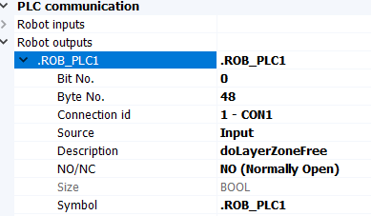

The signals marked as PLC IO are not needed in Experior but are only passed through Experior...

Similar description for Robot input signals…